**Line of Business Demos (***this content should be accessible from the Dept Reporting page and when a user clicks on the LOB demo link from the home page)*

The Line of Business demos provide a full set of assets and DVA files that can be accessed below or from Sales Central. These align with the Departmental Reporting ADW demo, and allow users to leverage and upload data sets to OAC or DVD to demonstrate the value of Oracle solutions to LOB analysts and business managers.

* **Take Control of Your Data and Analytics with Autonomous Data Warehouse** – includes a full set of customer facing demo videos, scripted demo walkthroughs and DVA/Excel files by LOB highlighting the power and value of ADW for analysts *(this takes users to first 2 tables below)*
* **Line of Business Analytics Dashboards** – PPT and DVA files showcasing analytics dashboards relevant to specific Line of Business managers *(this takes users to the third table below which is a summary of the current LOB demo content)*

**Take Control of Your Data and Analytics with Autonomous Data Warehouse**

Line of Business Assets

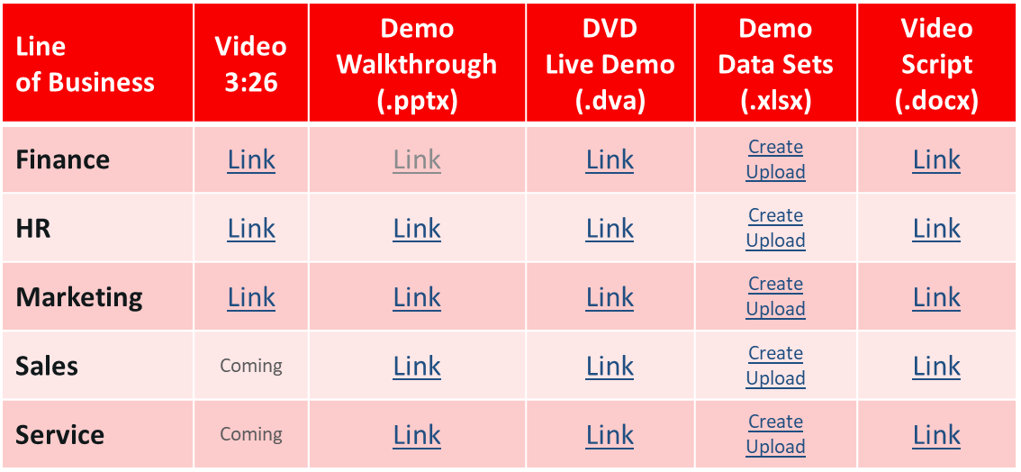

Cross Line of Business Assets

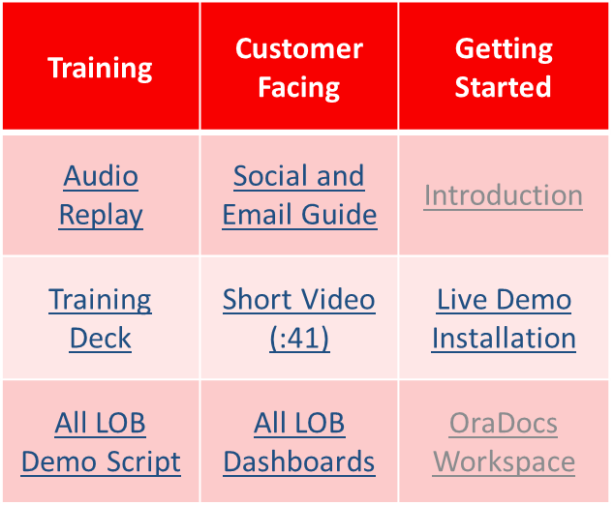

*Note: Use “ADWLOB” to find all videos in video.oracle.*

**Line of Business Analytics Dashboards**

The following demo assets showcase analytics dashboards relevant to specific Line of Business managers.

|  |  |  |  |
| --- | --- | --- | --- |
| **LOB** | **Canned Demo with Script** | **Demo Explanation** | **DVA for Live Demo** (Password: welcome)  *Note: Please use the CSV version – the loader database is not publicly accessible at this time* |
| **Finance** | [PPT](https://oradocs-corp.documents.us2.oraclecloud.com/documents/office/view/D1FEBC0F7EE12AC22FC22A19F6C3FF17C1177A968060) | [MP4](https://oradocs-corp.documents.us2.oraclecloud.com/documents/link/LD016DFAD44B94D21205D7D2F6C3FF17C1177A968060/fileview/D4C33B5779D8D632B9BC7F8BF6C3FF17C1177A968060/_Financial_Analytics.mp4) | [DVA](https://oradocs-corp.documents.us2.oraclecloud.com/documents/link/LD0D8955F0E37C71BCBB575DF6C3FF17C1177A968060/file/D49E9DCC45DAA0E6588D3A5BF6C3FF17C1177A968060/_Finance_Manager.dva) |
| **HR** | [PPT](https://oradocs-corp.documents.us2.oraclecloud.com/documents/office/view/D4C329F977A1FFFDFFA080FAF6C3FF17C1177A968060) | [MP4](https://oradocs-corp.documents.us2.oraclecloud.com/documents/link/LD09A99294B3B7BC7F4647D1F6C3FF17C1177A968060/fileview/DEC5BD1A31A5649FB61A740DF6C3FF17C1177A968060/_HR_Analytics.mp4) | [DVA](https://oradocs-corp.documents.us2.oraclecloud.com/documents/link/LD91F5F28A534AC09017D9EEF6C3FF17C1177A968060/file/D642486D2D4AB590F54E0FEEF6C3FF17C1177A968060/_HR_Analytics.dva) |
| **Marketing** | [PPT](https://oradocs-corp.documents.us2.oraclecloud.com/documents/office/view/D3780B3FCE69124A204457BDF6C3FF17C1177A968060) | [MP4](https://oradocs-corp.documents.us2.oraclecloud.com/documents/link/LD1C004200278A049C226DAFF6C3FF17C1177A968060/fileview/D1E7D4CD819F854C7B9DA1BEF6C3FF17C1177A968060/_Campaign_Analytics.mp4) | [DVA](https://oradocs-corp.documents.us2.oraclecloud.com/documents/link/LD5B7C5FF4A0E2335FC96C10F6C3FF17C1177A968060/file/D552EFCFFF6CF7AE9E4F385AF6C3FF17C1177A968060/_Marketing_Analyst.dva) |
| **Sales** | [PPT](https://oradocs-corp.documents.us2.oraclecloud.com/documents/office/view/D44AEF60215EA25C9BBD2C70F6C3FF17C1177A968060) | [MP4](https://oradocs-corp.documents.us2.oraclecloud.com/documents/link/LDF0625801231C3D6E81133EF6C3FF17C1177A968060/fileview/DF6E00299B3F1F4FB6F57169F6C3FF17C1177A968060/_Sales_Analytics.mp4) | [DVA](https://oradocs-corp.documents.us2.oraclecloud.com/documents/link/LD8598A12EBA413F51594265F6C3FF17C1177A968060/file/DA385DE1AE8A36CA23E8F89DF6C3FF17C1177A968060/_Sales_VP.dva) |
| **Procurement** | [PPT](https://oradocs-corp.documents.us2.oraclecloud.com/documents/office/view/D2E019C2009CDA4ED96B77DDF6C3FF17C1177A968060) | n/a | [DVA](https://oradocs-corp.documents.us2.oraclecloud.com/documents/link/LD2A8B189155450A0683C7EAF6C3FF17C1177A968060/file/DAFD003DDBF25A3BC2E063ABF6C3FF17C1177A968060/_Procurement_Manager.dva) |